Additional file 1
Table S1 Functional categories and fold changes of comparative expressionª (in form of log₂FC) of pairwise comparisons (YWD001-I vs YWD001-C and YWD005-I vs YWD005-C) of differentially expressed genes in tolerance to multiple inhibitors.
Seq ID | Gene | Description |  | YWD001-C fpkm | YWD001-I fpkm | log₂FC  (YWD001-I/YWD001-C) | YWD005-C fpkm | YWD005-I fpkm | log₂FC  (YWD005-I/YWD005-C)
DEGs related to NADH and NADPH-dependent proteins
Central carbon metabolism
KMAR_10659 | XR |  | NADPH-dependent D-xylose reductase | 782.13 | 154.77 | -1.98 | 738.84 | 139.21 | -1.90
KMAR_20285 | TDH2 |  | glyceraldehyde-3-phosphate dehydrogenase 2 | 5.51 | 16.49 | 1.94 | 4.48 | 19.32 | 2.62
KMAR_80296 | ADH3 |  | alcohol dehydrogenase III | 31.75 | 6.06 | -2.03 | 17.78 | 5.49 | -1.18
KMAR_20152 | ADH4 |  | alcohol dehydrogenase 4 | 318.33 | 31.44 | -2.98 | 452.78 | 39.68 | -3.00
KMAR_80326 | ADH6 |  | NADP-dependent alcohol dehydrogenase 6 | 193.87 | 6505.20 | 5.43 | 90.06 | 6699.52 | 6.73
KMAR_20637 | ALD2 |  | aldehyde dehydrogenase [NAD(P)+] | 35.58 | 10.33 | -1.42 | 29.02 | 11.69 | -0.79
KMAR_40408 | ALD5 |  | aldehyde dehydrogenase 5 | 58.30 | 16.84 | -1.43 | 103.45 | 14.74 | -2.29
KMAR_30696 | GUT2 |  | glycerol-3-phosphate dehydrogenase | 16.40 | 4.84 | -1.39 | 17.92 | 4.85 | -1.36
KMAR_60328 | MAE1 |  | NAD-dependent malic enzyme | 132.41 | 487.64 | 2.25 | 173.16 | 552.54 | 2.20
KMAR_60167 | MDH2 |  | malate dehydrogenase | 1557.56 | 2456.60 | 1.01 | 1184.36 | 2224.55 | 1.42
KMAR_20443 | SDH1 |  | succinate dehydrogenase [ubiquinone] | 531.49 | 1410.57 | 1.78 | 416.82 | 1422.53 | 2.28
KMAR_30112 | SDH3 |  | succinate dehydrogenase [ubiquinone] | 790.26 | 1486.46 | 1.23 | 532.50 | 1396.27 | 1.86
KMAR_50521 | SDH4 |  | succinate dehydrogenase [ubiquinone] | 275.12 | 767.50 | 1.79 | 209.08 | 735.92 | 2.27
Glutamate metabolism
KMAR_50015 | GDH1 |  | NADP-specific glutamate dehydrogenase 2 | 410.62 | 1613.04 | 2.34 | 316.63 | 1232.59 | 2.48
KMAR_20698 | GDH2 |  | NAD-specific glutamate dehydrogenase | 73.48 | 15.77 | -1.85 | 84.66 | 16.75 | -1.81
KMAR_60127 | UGA2 |  | succinate-semialdehyde dehydrogenase [NADP+] | 176.66 | 276.00 | 1.01 | 94.80 | 253.94 | 1.94
Others
KMAR_40373 | LYS1 |  | saccharopine dehydrogenase [NAD+] | 373.81 | 764.98 | 1.39 | 279.02 | 692.76 | 1.83
KMAR_10058 |  |  | putative NADPH dehydrogenase C23G7.10c | 193.38 | 396.04 | 1.40 | 180.40 | 415.30 | 1.72
KMAR_30702 |  |  | putative uncharacterized oxidoreductase YGL039W | 91.01 | 326.66 | 2.09 | 51.11 | 258.29 | 2.61
KMAR_40624 | GRE2 |  | NADPH-dependent methylglyoxal reductase GRE2 | 593.39 | 4682.50 | 3.34 | 367.83 | 3905.15 | 3.92
KMAR_50448 |  |  | sulfite reductase [NADPH] | 109.90 | 170.95 | 1.01 | 51.34 | 141.10 | 1.99
NAD+ biosynthetic enzymes and nicotinate metabolism
KMAR_50064 | BNA3 |  | probable kynurenine--oxoglutarate transaminase BNA3 | 269.04 | 642.30 | 1.61 | 109.52 | 499.84 | 2.70
KMAR_30218 | FUN26 |  | nucleoside transporter FUN26 | 36.89 | 96.93 | 1.76 | 34.72 | 92.71 | 1.94
KMAR_40275 | PNC1 |  | nicotinamidase | 196.41 | 62.21 | -1.32 | 177.70 | 59.02 | -1.11
KMAR_40052 | NMNAT |  | nicotinamide-nucleotide adenylyltransferase 1 | 202.07 | 949.06 | 2.60 | 183.83 | 935.53 | 2.87
KMAR_10267 | URH1 |  | uridine nucleosidase | 30.29 | 144.65 | 2.61 | 24.28 | 171.93 | 3.33
KMAR_10620 | NUDT12 |  | NADH pyrophosphatase | 67.79 | 237.99 | 2.17 | 40.19 | 231.27 | 3.04
Mitochondrial respiratory chain
NADH dehydrogenase
KMAR_10252 | NDI1 |  | rotenone-insensitive NADH-ubiquinone oxidoreductase | 116.60 | 232.84 | 1.36 | 108.36 | 251.74 | 1.74
KMAR_10671 | NDH1 |  | external NADH-ubiquinone oxidoreductase 1 | 263.79 | 1011.58 | 2.33 | 220.59 | 1029.66 | 2.75
Succinate dehydrogenase
KMAR_20443 | SDH1 |  | succinate dehydrogenase [ubiquinone] | 531.49 | 1410.57 | 1.78 | 416.82 | 1422.53 | 2.28
KMAR_30112 | SDH3 |  | succinate dehydrogenase [ubiquinone] | 790.26 | 1486.46 | 1.23 | 532.50 | 1396.27 | 1.86
KMAR_50521 | SDH4 |  | succinate dehydrogenase [ubiquinone] | 275.12 | 767.50 | 1.79 | 209.08 | 735.92 | 2.27
Cytochrome c oxidase
KMAR_90002 | COX2 |  | cytochrome c oxidase subunit 2 | 0.56 | 1.92 | 2.12 | 0.58 | 2.00 | 2.26
Fatty acid biosynthesis and elongation
KMAR_30147 | PHS1 |  | protein PHS1 | 143.88 | 34.60 | -1.72 | 176.07 | 32.88 | -1.94
KMAR_10176 | TSC13 |  | enoyl reductase TSC13 | 216.10 | 67.10 | -1.33 | 235.58 | 66.32 | -1.32
KMAR_10140 | ELO2 |  | elongation of fatty acids protein 2 | 215.23 | 53.86 | -1.64 | 281.91 | 52.29 | -1.92
KMAR_60262 | MECR |  | probable trans-2-enoyl-CoA reductase | 573.72 | 1791.16 | 2.00 | 391.72 | 1667.72 | 2.60
KMAR_60084 | ACOT1_2_4 |  | peroxisomal acyl-coenzyme A thioester hydrolase 1 | 151.00 | 48.24 | -1.29 | 130.94 | 47.98 | -0.94
KMAR_10220 | OLE1 |  | acyl-CoA desaturase 1 | 3158.93 | 1105.93 | -1.15 | 4277.64 | 1112.68 | -1.42
KMAR_40523 | FAS1 |  | fatty acid synthase subunit beta | 83.97 | 12.21 | -2.32 | 104.78 | 14.28 | -2.27
KMAR_70200 | FAS2 |  | fatty acid synthase subunit alpha | 370.25 | 114.02 | -1.32 | 488.22 | 119.96 | -1.49
Fatty acid degradation
KMAR_10192 | PECI |  | 3,2-trans-enoyl-CoA isomerase | 12.10 | 21.73 | 1.20 | 7.78 | 21.43 | 1.96
KMAR_60375 | ERG10 |  | acetyl-CoA acetyltransferase | 410.09 | 157.75 | -1.02 | 600.35 | 148.05 | -1.50
KMAR_60033 | ACADM, ACD |  | acyl-CoA dehydrogenase family member 11 | 1.97 | 37.84 | 4.63 | 0.85 | 38.62 | 6.03
KMAR_80296 | ADH3 |  | alcohol dehydrogenase III | 31.75 | 6.06 | -2.03 | 17.78 | 5.49 | -1.18
KMAR_20152 | ADH4 |  | alcohol dehydrogenase 4 | 318.33 | 31.44 | -2.98 | 452.78 | 39.68 | -3.00
KMAR_40408 | ALD5 |  | aldehyde dehydrogenase 5 | 58.30 | 16.84 | -1.43 | 103.45 | 14.74 | -2.29
redox related protein
KMAR_70075 | SOD1 |  | Cu/Zn superoxidedismutase | 370.40 | 4151.37 | 3.79 | 252.75 | 3266.87 | 4.13
KMAR_20527 | SOD2 |  | superoxide dismutase [Mn] | 490.64 | 966.51 | 1.32 | 334.13 | 835.44 | 1.81
KMAR_40317 |  |  | superoxide dismutase 1 copper chaperone | 302.10 | 724.70 | 1.61 | 259.72 | 699.16 | 1.92
KMAR_50400 | CTT1 |  | catalase T | 1953.39 | 577.94 | -1.39 | 1850.05 | 510.75 | -1.33
KMAR_10658 | TRR1 |  | thioredoxin reductase | 1490.87 | 2419.97 | 1.06 | 1291.45 | 2204.93 | 1.28
KMAR_80342 | PRX1 |  | mitochondrial peroxiredoxin PRX1 | 775.67 | 4239.09 | 2.80 | 334.53 | 3899.19 | 4.04
KMAR_20388 | HYR1 |  | peroxiredoxin HYR1 | 261.11 | 717.38 | 1.79 | 306.75 | 615.62 | 1.48
KMAR_50387 | DOT5 |  | peroxiredoxin DOT5 | 525.71 | 87.35 | -2.25 | 543.16 | 84.97 | -2.20
KMAR_10650 | GPX2 |  | glutathione peroxidase 2 | 43.20 | 129.86 | 1.90 | 46.57 | 149.99 | 2.14
KMAR_30143 | GSH1 |  | glutamate--cysteine ligase | 352.51 | 696.73 | 1.35 | 287.61 | 624.80 | 1.65
KMAR_30340 | GRX5 |  | monothiol glutaredoxin-5 | 368.42 | 1280.56 | 2.16 | 309.69 | 1256.28 | 2.52
ª Only differentially expressed genes were presented in the table. I and C represent samples of yeast grown on medium with or without multiple inhibitors in YPD under aerobic condition.
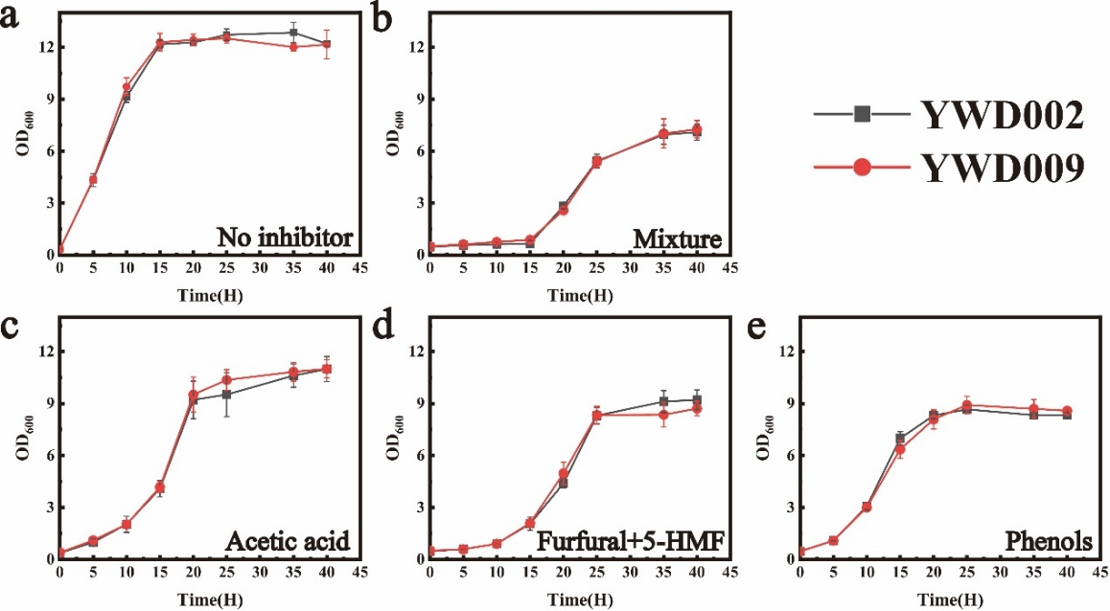
Fig. S1 The growth of YWD002, YWD009 in YPD with the presence of inhibitor. a) no inhibitor, b) inhibitor mixture, c) acetic acid, d) furfural + 5-HMF, or e) phenols. All values are the means of three biological replicates ± standard deviation at each of the time points.

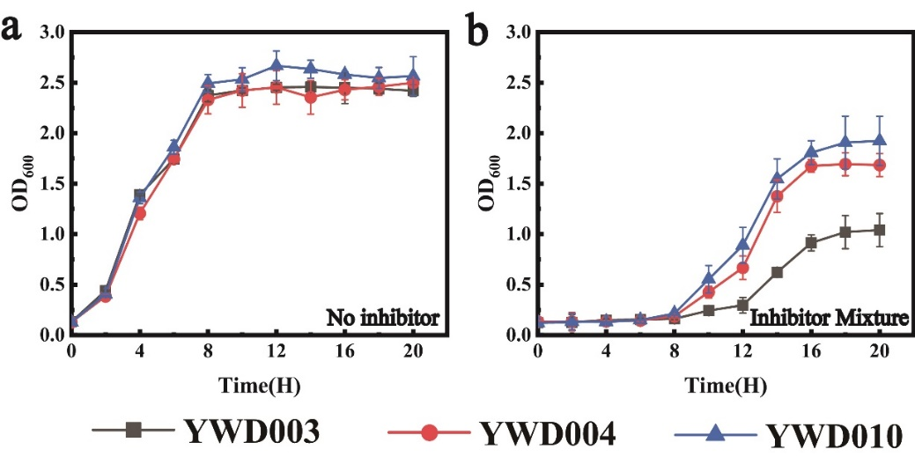
Fig. S2 The growth of YWD003, YWD004, YWD010 cultured in SD medium with the presence of inhibitor. a) Without inhibitor. b) With inhibitor mixture (1.0 g/l acetic acid, 0.25 g/l furfural, 0.25 g/l 5-HMF, 0.1 g/l phenols). All values are the means of three biological replicates ± standard deviation at each of the time points.

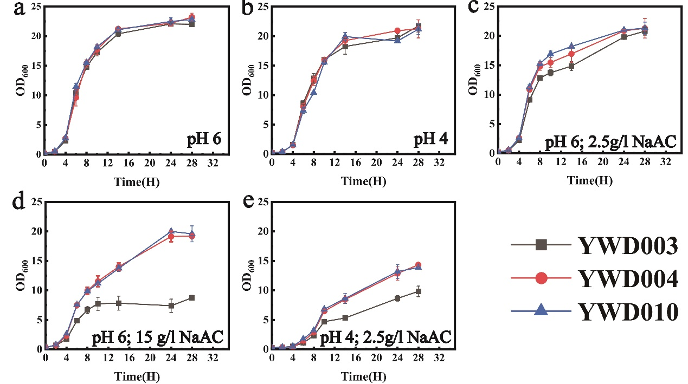
Fig. S3 The growth of YWD003, YWD004 and YWD010 in YPD medium with the presence of inhibitor. a) no acetic acid, pH 6, b) no acetic acid, pH 4, c) 2.5 g/l acetic acid, pH 6, d) 15 g/l acetic acid, pH 6. e) 2.5 g/l acetic acid, pH 4. All values are the means of three biological replicates ± standard deviation at each of the time points.

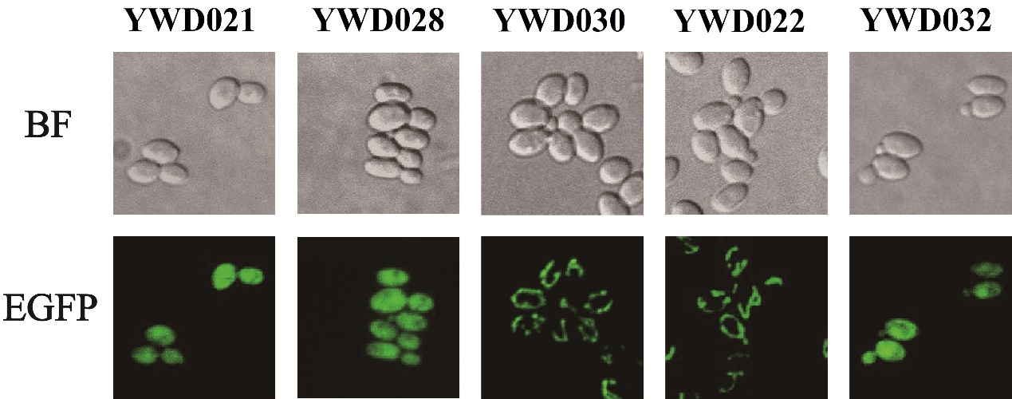
Fig. S4 Identify the mitochondrial signal peptide with truncated KmYME - EGFP. YWD021 (EGFP only), YWD028 (1-20 aa), YWD030 (1-40 aa), YWD022 (1-360 aa, full length), YWD032 (41-360 aa).
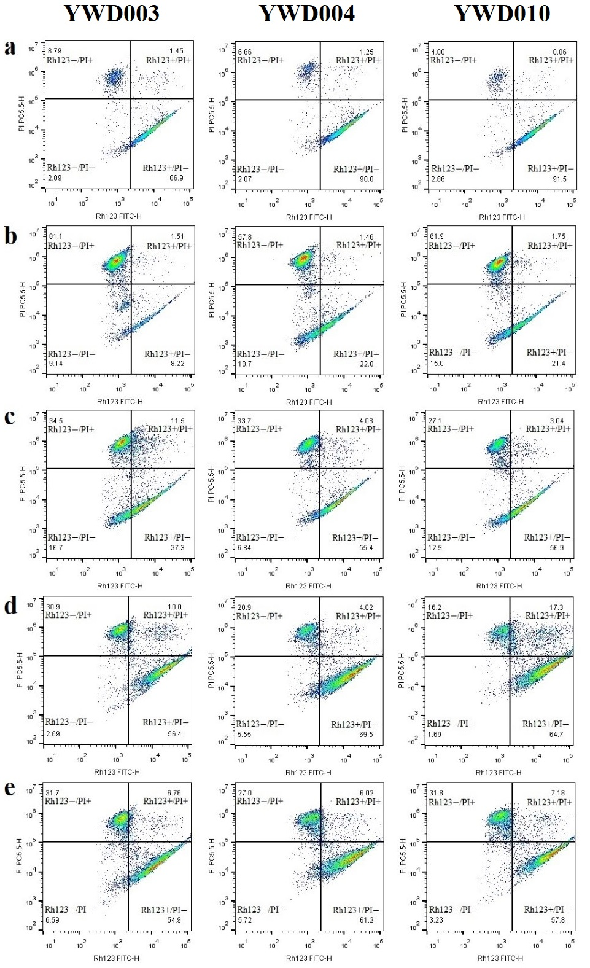
Fig. S5 Flow cytometric analysis of Rh123 and PI double fluorescent staining. YWD003, YWD004, YWD010 stimulated with a) no inhibitors, b) inhibitor mixture, c) acetic acid, d) furfural and 5-HMF, or e) phenols. Rh123⁺/PI⁻ presents viable cells with normal MMP and intact plasma membrane. Rh123⁻/PI⁻ presents live cells with losing MMP. Rh123⁻/PI⁺ presents dead cells with losing MMP.
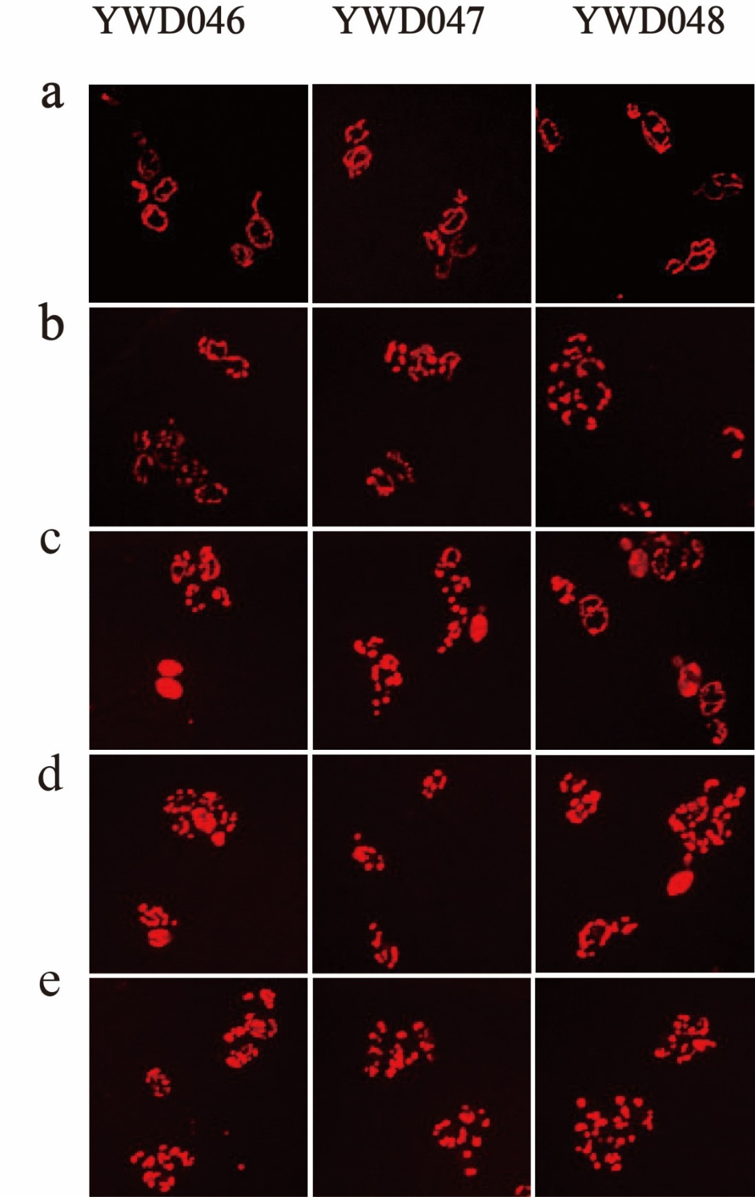
Fig. S6 Mitochondria morphology analysis. YWD046, YWD047 and YWD048 were cultivated in YPD medium containing a) no inhibitors, b) inhibitor mixture, c) acetic acid, d) furfural and 5-HMF, e) phenols.
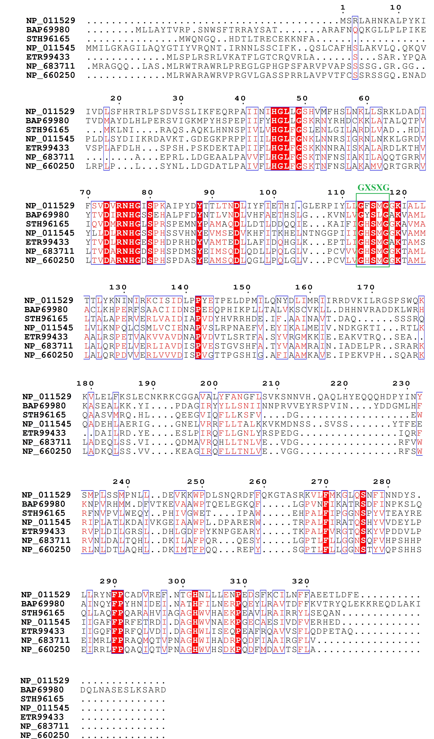
Fig. S7 Alignment of amino acid sequences of KmYME and homologous proteins. The common conservative structural domain (GXSXG) is shown in green box. The order of the species from top to bottom is Saccharomyces cerevisiae S288C, Kluyveromyces marxianus, Escherichia coli, Saccharomyces cerevisiae S288C, Trichoderma reesei RUT C-30, Homo sapiens, and Mus musculus, respectively.
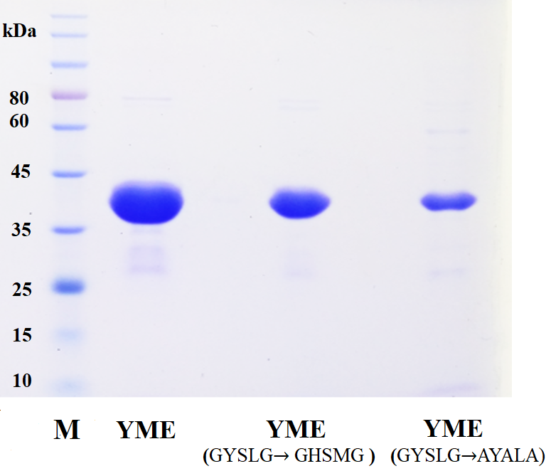

Fig. S8 SDS-PAGE analysis of purified proteins of KmYME and mutants. Molecular weight: about 40 kDa.

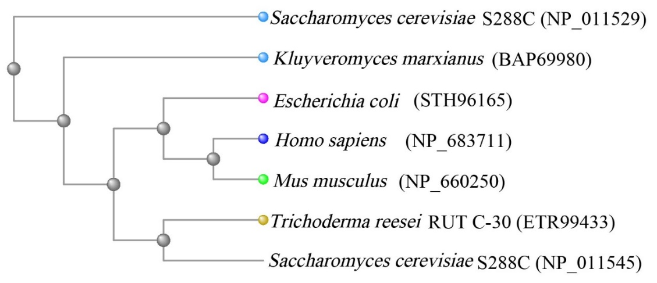
Fig. S9 Phylogenetic tree of KmYME and possible homologous proteins in other species. The tree was established by using a web tool cobalt (https://www.ncbi.nlm.nih.gov/tools/cobalt/ ).

